### Install Basic tools ###

[root@pg1 ~]# vi /etc/selinux/config

SELINUX= disabled

[root@pg1 ~]# init 6

[root@pg1 ~]# dnf install net-tools

[root@pg1 ~]# dnf install telnet

[root@pg1 ~]# dnf install git

[root@pg1 ~]# dnf install wget

[root@pg1 ~]# netstat -tulpn

### Install Java ###

[root@pg1 ~]# dnf install java

Installing:

java-11-openjdk x86_64 1:11.0.24.0.8-2.el9 appstream 434 k

[root@pg1 ~]# java -version

### Install Docker ####

[root@pg1 ~]# dnf remove docker \

docker-client \

docker-client-latest \

docker-common \

docker-latest \

docker-latest-logrotate \

docker-logrotate \

docker-engine \

podman \

runc

[root@pg1 ~]# yum install -y yum-utils

[root@pg1 ~]# yum-config-manager --add-repo <https://download.docker.com/linux/rhel/docker-ce.repo>

[root@pg1 ~]# sudo yum install docker-ce docker-ce-cli containerd.io docker-buildx-plugin docker-compose-plugin

[root@pg1 ~]# systemctl start docker

[root@pg1 ~]# systemctl enable docker

[root@pg1 ~]# systemctl stop docker

[root@pg1 ~]# systemctl status docker

### Install Jenkins ###

sudo wget -O /etc/yum.repos.d/jenkins.repo \

<https://pkg.jenkins.io/redhat-stable/jenkins.repo>

sudo rpm --import https://pkg.jenkins.io/redhat-stable/jenkins.io-2023.key

sudo yum upgrade

sudo yum install jenkins

sudo systemctl daemon-reload

sudo systemctl start jenkins

sudo systemctl stop jenkins

sudo systemctl status jenkins

cat /var/lib/jenkins/secrets/initialAdminPassword

Jenkins Key: f8066e36c9494d8e8344604b9ea4a4fc

<http://192.168.141.138:8080>

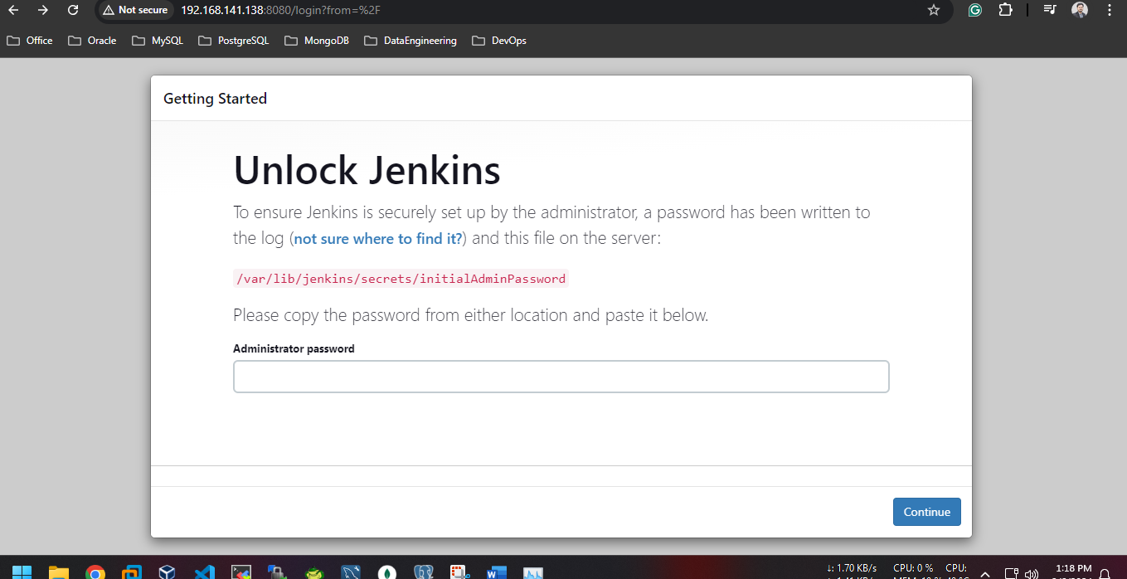

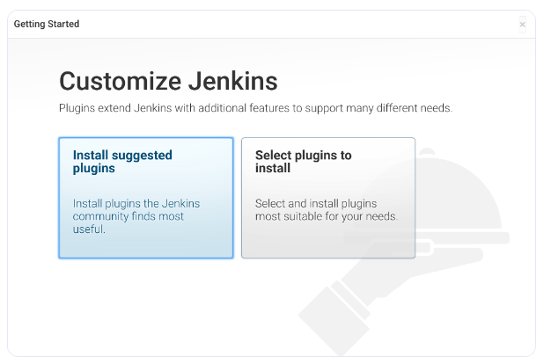

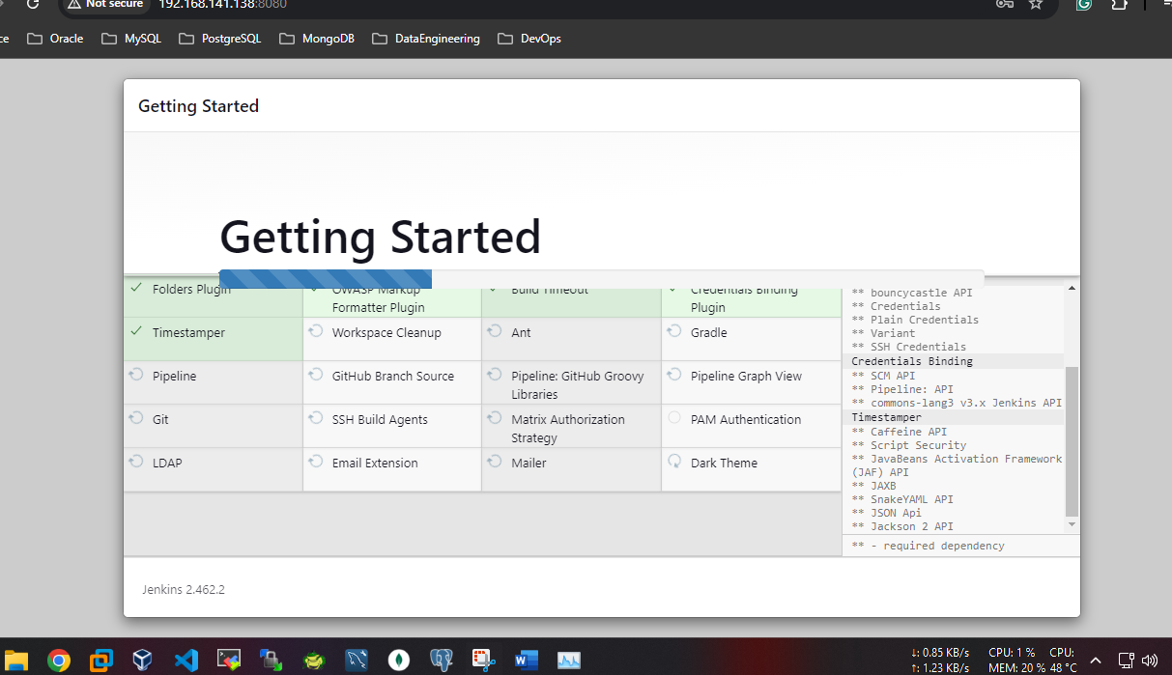

User: admin

Pass: admin

### CI with Github ###

# give permission to Jenkins for docker

[root@pg1 ~]# usermod -aG docker jenkins

[root@pg1 ~]# systemctl restart jenkins

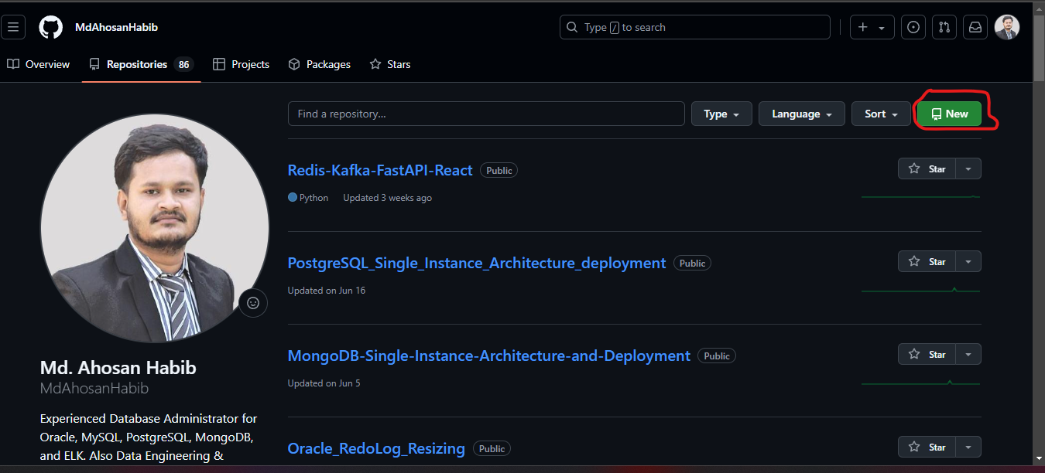

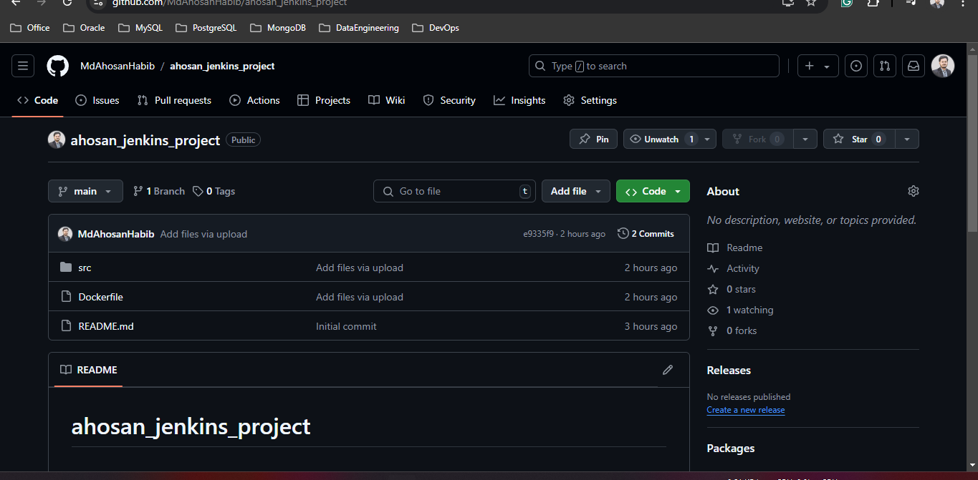

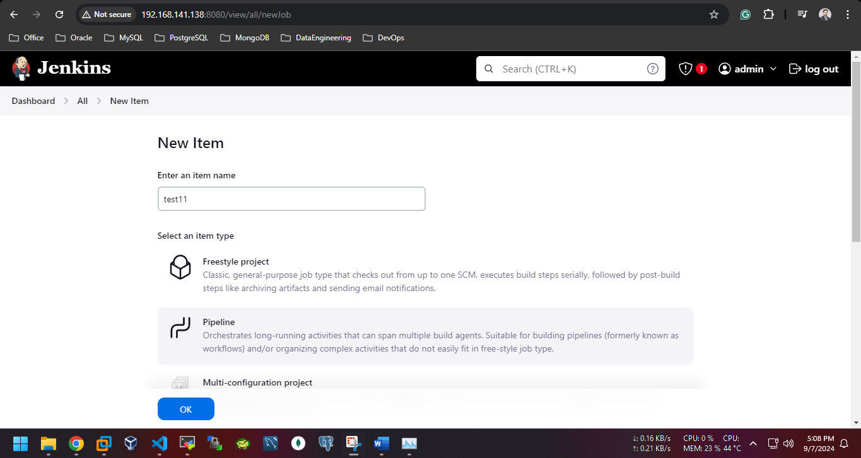

# jenkins source code

pipeline {

agent any

environment {

IMAGE_NAME = 'ahosan_jenkins_project_image'

CONTAINER_NAME = 'ahosan_jenkins_project_container'

}

stages {

stage('Checkout') {

steps {

// Checkout the code from the GitHub repository

checkout scmGit(branches: [[name: 'main']], extensions: [], userRemoteConfigs: [[url: 'https://github.com/MdAhosanHabib/ahosan_jenkins_project.git']])

}

}

stage('Build Docker Image') {

steps {

script {

// Build the Docker image using the Dockerfile from the repository

sh """

docker build -t ${IMAGE_NAME}:latest .

"""

}

}

}

stage('Run Docker Container') {

steps {

script {

// Stop and remove any existing container with the same name

sh """

docker stop ${CONTAINER_NAME} || true

docker rm ${CONTAINER_NAME} || true

"""

// Run the Docker container

sh """

docker run -d --name ${CONTAINER_NAME} -p 8181:80 ${IMAGE_NAME}:latest

"""

}

}

}

}

}

